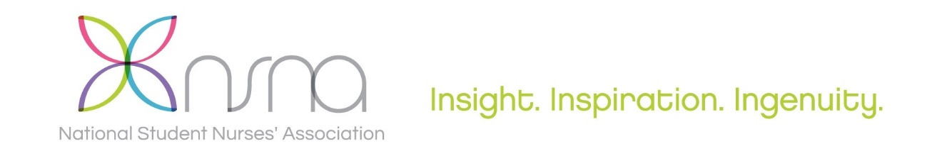

NSNA 67th Annual Convention
Salt Palace Convention Center • Salt Lake City, UT
April 3-7, 2019

CREDIT CARD PAYMENT AUTHORIZATION FORM

NSNA will accept payment by Credit Card for booth space fees, program book ad space reservations, additional exhibitor name badges, and marketing opportunities offered only to NSNA 67th Annual Convention’s confirmed exhibitors.

NSNA Credit Card payment rates will apply and NSNA payment discounts are forfeited when not paying by check. NSNA does not accept onsite payment of booth fees. All booths must be fully paid by April 1, 2019 to enable onsite set-up release.

Please return the completed NSNA payment authorization for by fax, or scan copy, to:
Lauren McKeown, NSNA Marketing Coordinator
Email: lauren.mckeown@ajj.com; Fax: 856-589-7463

Please indicate the type of credit card being authorized: (NSNA Federal Tax ID Number: 13-6081991)

☐ Visa ☐ MasterCard NO AMEX ACCEPTED
Charge credit card indicated below in the amount of: $
In payment of:

Company Name:
Contact Name:
Contact Phone Number:
Contact Email Address:

Name on Credit Card:
Credit Card Number:
Expiration Date: Security Code:
Card Holder Signature:

Please direct any questions to nncc_exhibits@ajj.com

Convention and National Marketing Representatives:
Anthony J. Jannetti, Inc. * East Holly Avenue Box 56 * Pitman, NJ 08071-0056 / Phone 856.256.2432 FAX 856.589.7463

